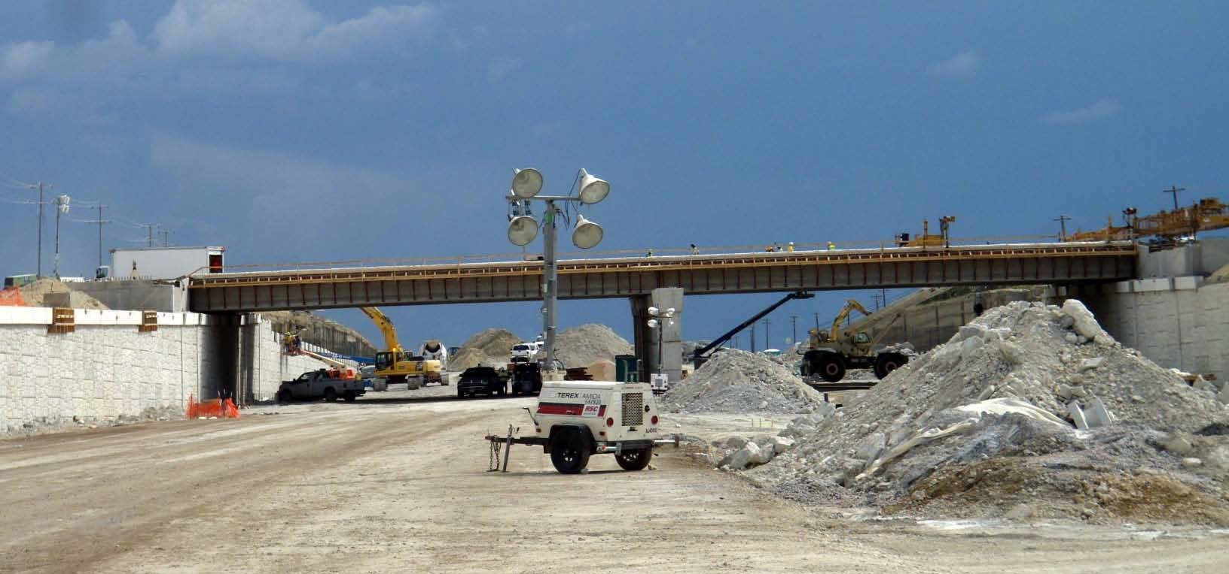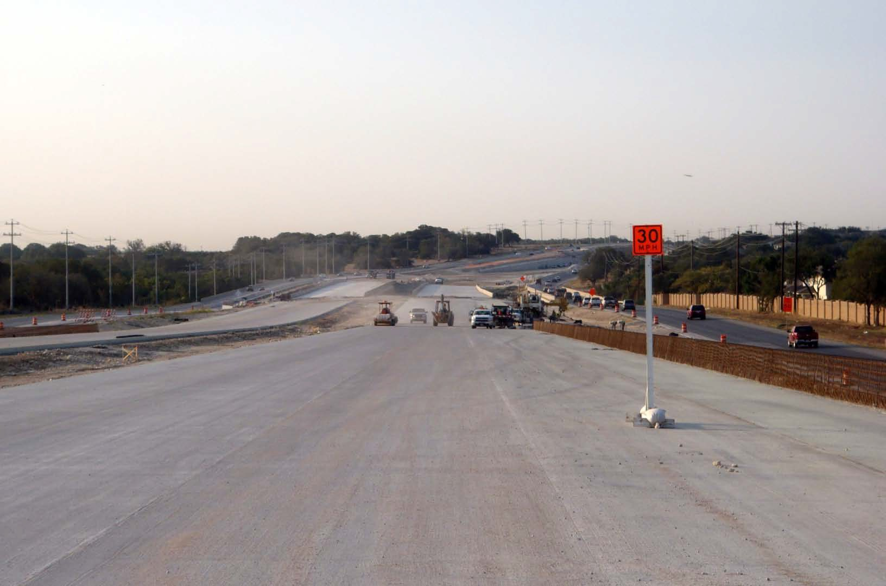

**183A TURNPIKE - PHASE II**

**QUARTERLY CONSTRUCTION PROGRESS REPORT**

**No. 6 | October 2011**

**INDEPENDENT ENGINEERING REPORT**



## Board of Directors

Ray A. Wilkerson, Chairman James H. Mills, Vice-Chairman Robert L. Bennett, Jr., Treasurer Henry H. Gilmore

Nikelle S. Meade David Singleton Charles Heimsath

## Executive Director

Mike Heiligenstein

## General Engineering Consultant (GEC)



**Construction Contractor**



183A TURNPIKE - PHASE II

**Quarterly Construction**

**Progress Report**

No. 6

# TABLE OF CONTENTS

|  |  |
| --- | --- |
| **Introduction** | **1** |
| **Project Description** | **1** |
| **Construction Activities** | **3** |
| **Project Progress** | **7** |
| **Project Financial Status** | **8** |
| **DBE Status** | **10** |
| **Employment Reporting Status** | **11** |
| **Sustainability** | **11** |
| **Public Involvement** | **11** |

**List of Figures, Maps and Tables**

|  |  |  |
| --- | --- | --- |
| **Figure 1** | **Project Location** | **2** |
| **Table 1** | **183A Phase II Construction Progress** | **7** |
| **Table 2** | **Schedule of Project Milestones** | **7** |
| **Figure 2** | **Project Baseline Cash Flow Curve** | **9** |
| **Figure 3** | **DBE Construction Commitment vs. Payment** | **10** |

183A TURNPIKE - PHASE II

**Quarterly Construction**

**Progress Report**

No. 6

# INTRODUCTION

This report documents and describes the second phase of the 183A Turnpike Project construction from July 1, 2011 to September 31, 2011. This project is an extension of the existing 183A toll road facility and is being constructed by the Central Texas Regional Mobility Authority (Mobility Authority). The project is funded entirely from toll revenue bonds.

# PROJECT DESCRIPTION

Phase II of the 183A Turnpike Project is located in southwestern Williamson County and extends approximately 5.1 miles, traversing through the cities of Cedar Park and Leander in the State of Texas. The Project extends the mainlanes of the existing 183A Turnpike from FM 1431 to north of RM 2243. This limited-access toll road will be constructed between the existing frontage roads – which were constructed as part of the initial phase of the Project – and the added capacity will consist of three lanes in each direction with access ramps connecting to the frontage roads. It is located east of, and parallel to, the existing US 183 facility. See Figure 1 for the Project Map.

The construction tasks principally include: preparation of right-of-way; excavation and embankment; flexible base / cement treated base; warm mix asphalt; concrete pavement; concrete curb and gutter; roadway bridges; retaining walls; drill shafts; rip rap; concrete box culverts and other drainage structures; water quality ponds; barricades, signs, and traffic handling; illumination; overhead sign supports; traffic / pedestrian signal head, pole, and detectors; a pedestrian bridge; toll facilities; and ITS ducts.

The Mobility Authority entered into a contract with Webber LLC Contractors (Webber) to construct the 183A Phase II Project. The agreement requires the project to be substantially complete by March 2012. The Contractor has developed an acceptable Baseline CPM (Critical Path Method) Schedule for the Project. The Mobility Authority issued Notices to Proceed (NTP) for NTP 1 and NTP 2 on March 24, 2010, in accordance with the terms of the contract. An Alternative Bid NTP was granted on May 7, 2010; and NTP 3 was issued on November 24, 2010.

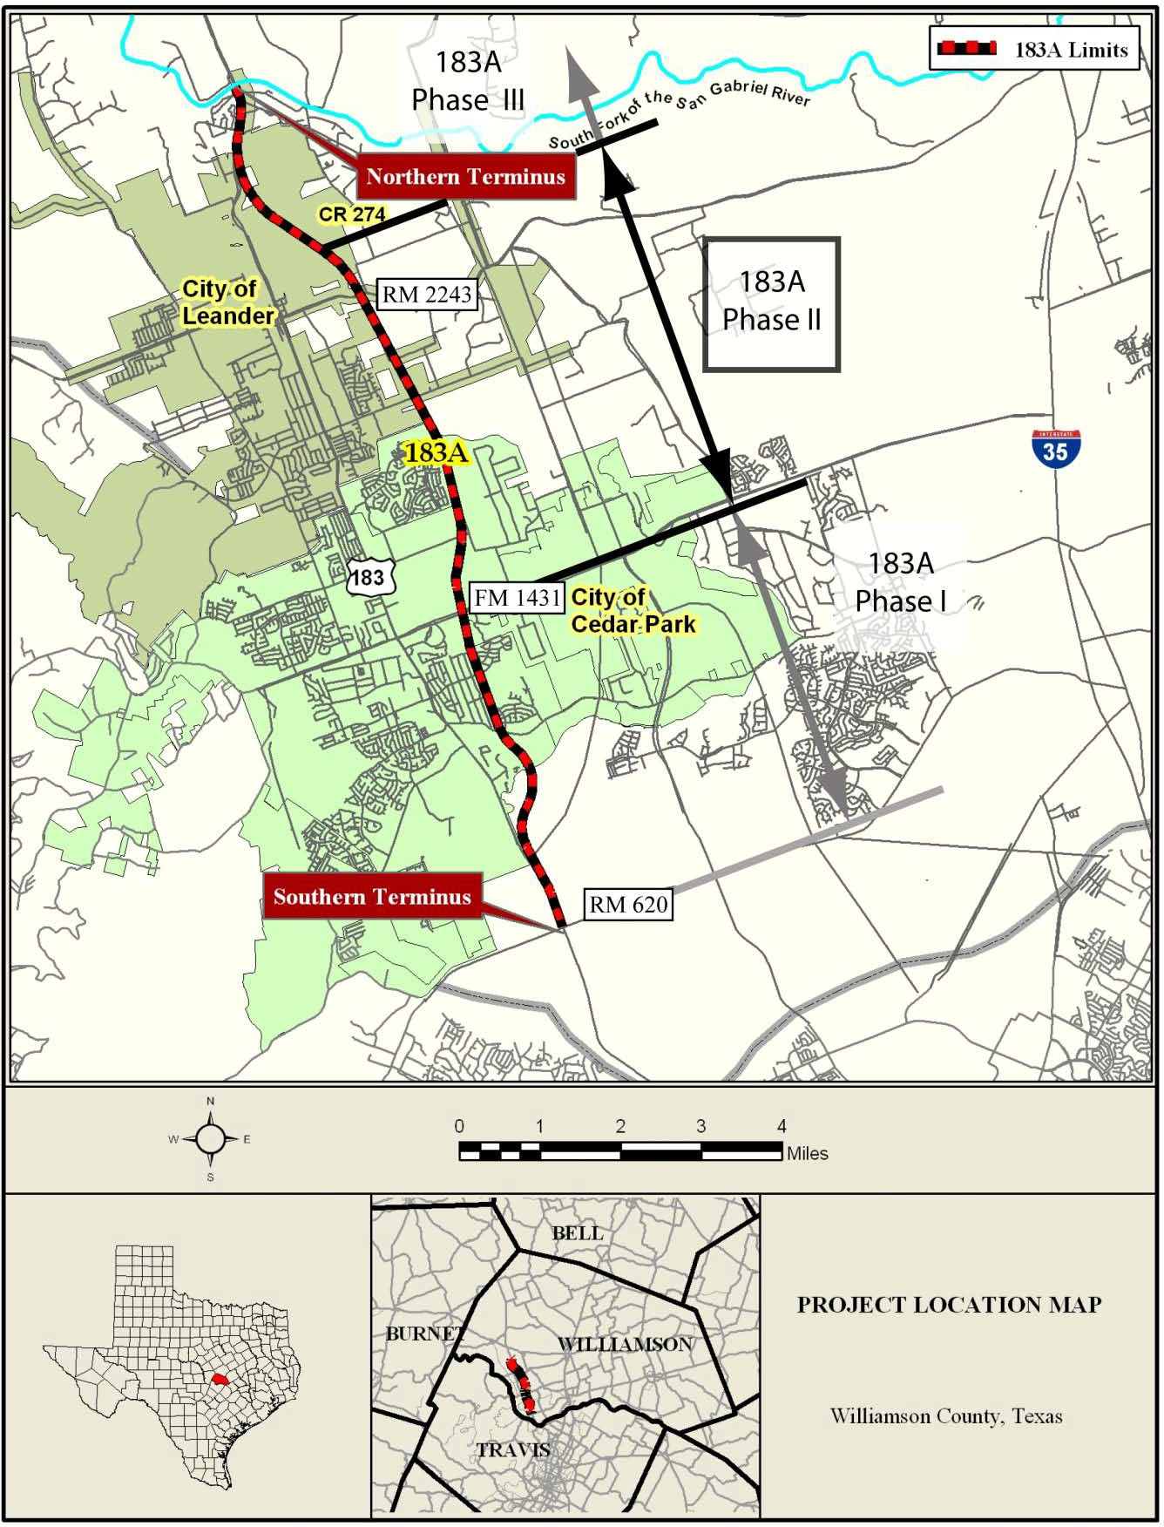

**Figure 1: Project Location**

# CONSTRUCTION ACTIVITIES

Construction of 183A Phase II is 75% complete. The team is currently on schedule to open the five mile tolled expressway in the spring of 2012.

Progress for the period is highlighted by continued mainlane roadway paving throughout the project as well as bridge construction at Scottsdale Drive. It is anticipated that the new bridges over Scottsdale Drive will be open to the traveling public in late October 2011. This period also marked the start of concrete bridge railing placement.

Other activities include toll gantry foundation work, sign column construction, and construction of drainage facilities across the project area. Block wall placement and preparation for rock lining is occurring in the project's multiple water quality ponds. Construction also continues on the pedestrian bridges for the Shared Use Path component of the 183A Phase II construction.

The following tasks continue from the last reporting period: concrete production at the Contractor’s temporary concrete batch plant facility; coordination with Telvent, the project's toll integrator contractor; soil nail wall construction at Scottsdale Drive; MSE wall placement throughout the project area; ongoing traffic control activities; and erosion control.

The Mobility Authority's GEC continues to perform construction inspection and oversight of the Contractor, including all materials testing. Offsite material fabrication plant inspections continue to take place.

### 082011_Bridge construction at Scottsdale with Block House Creek BeyondThe Cut at Scottsdale Drive

Webber has concentrated efforts on finishing the Scottsdale Drive bridges over the depressed 183A mainlanes before the end of October.

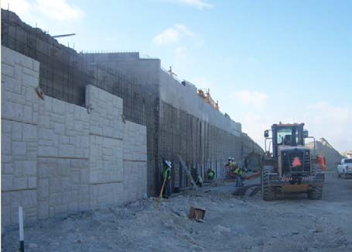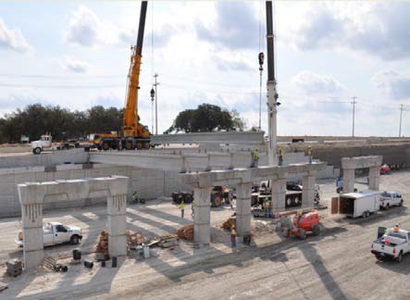

Bridge construction at Scottsdale Drive with Block House Creek beyond

Soil nail wall construction at Scottsdale Drive

Bridge structure work at Scottsdale Drive

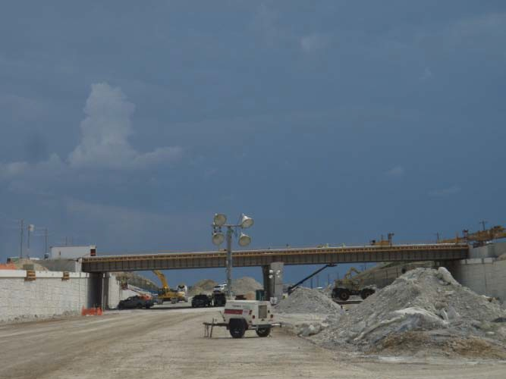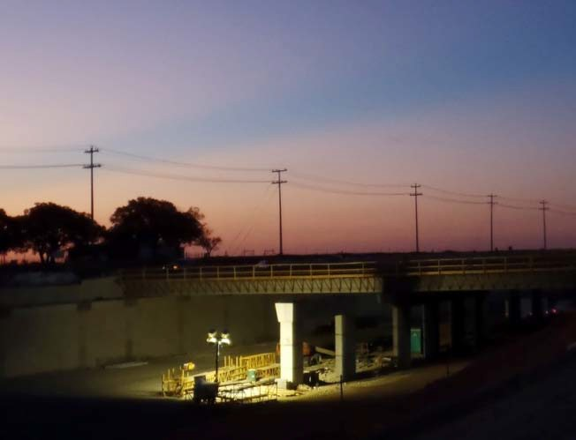

Looking northward at the Scottsdale Drive Bridges

Night work to complete concrete placement on the bridge deck

### Mainlane Paving

Across the project, Webber has been preparing for and pouring concrete for the future 183A mainlanes.

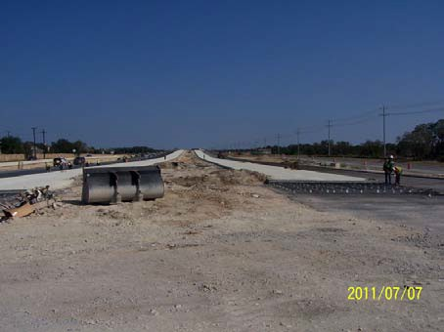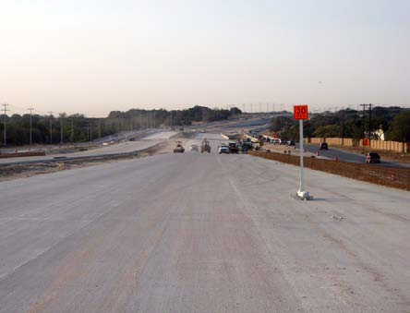

Reinforcing steel for mainlane concrete paving

Mainlane concrete pavement

from Block House Creek and Crystal Falls

Main lane concrete pavement from Crystal Falls Parkway to Block House Creek

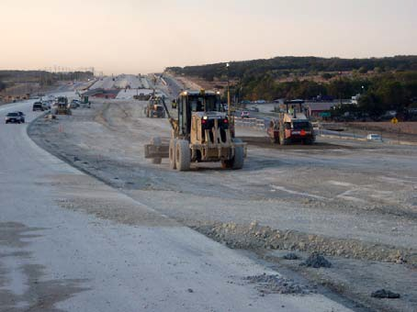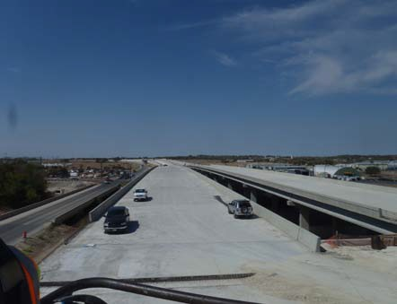

Construction of the main lanes from Hero Way to RM 2243

Looking north from the bridges over RM 2243

### 092011_Placing prefabricated bridge deck panels at the Block House Creek bridgesOther Construction Activities

Progress continues throughout the project.

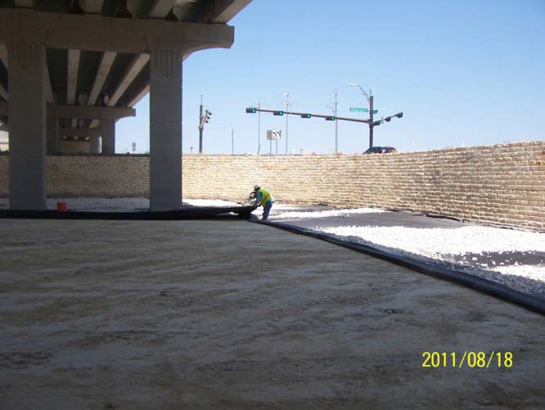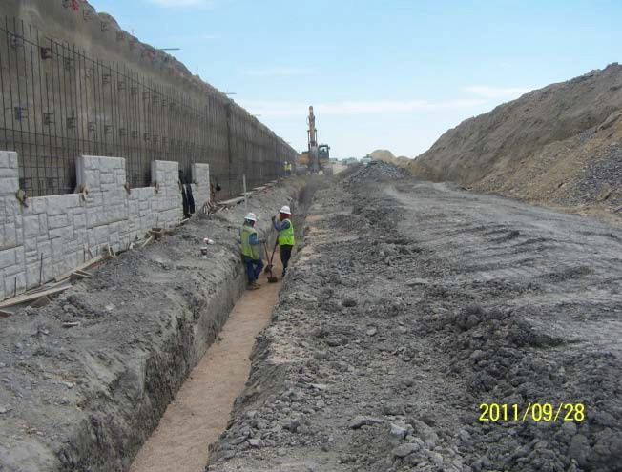

Placing prefabricated bridge deck panels at the Block House Creek bridges

Preparing for rock lining of the stormwater detention pond south of Crystal Falls

Installing stormwater drainage system at the cut at Scottsdale Drive

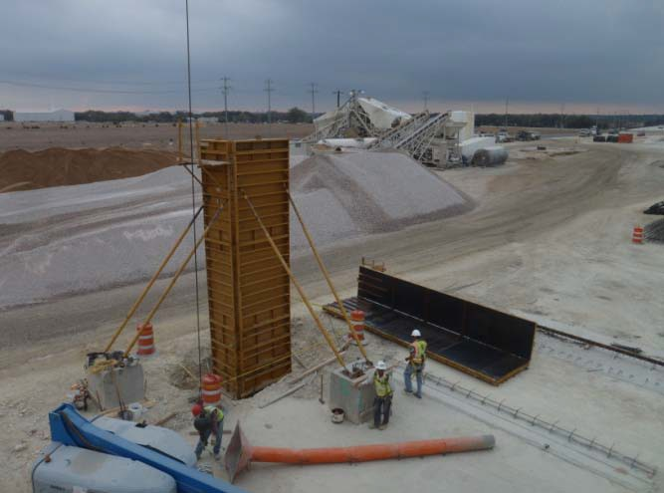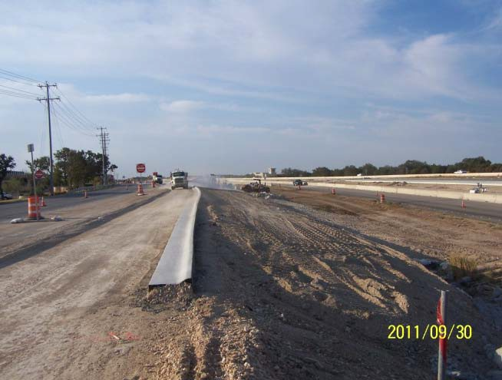

Preparations for an exit ramp toll gantry

Construction of a new temporary northbound exit ramp for New Hope

# PROJECT PROGRESS

Based on the assessment of the Contractor's activities and progress, the summary of the construction progress achieved on work tasks through the end of September 2011 is as follows:

**Table 1:**

**183A Phase II Construction Progress for Period Ending September 2011**

|  |  |
| --- | --- |
| **Construction Tasks** | **% Complete** |
| Earthwork / Excavation / Embankment | 95% |
| Stormwater Protection | 70% |
| Drainage Structures | 85% |
| Bridge Substructures | 95% |
| Bridge Superstructure | 85% |
| Retaining Walls | 95% |
| Pavement Base | 80% |
| Roadway Concrete Paving | 65% |
| Asphalt Paving | 25% |
| Toll Structures | 20% |
| Electrical/Lighting / Signing / Signals | 50% |
| Landscaping | 0% |

The assessment of the Contractor’s progress against their acceptable Baseline CPM (Critical Path Method) schedule for the reporting period indicates that the Contractor is maintaining schedule and forecasting an early project completion on March 8th, 2012. There are no identified threats to the schedule at this time. **The Project is currently ahead of the contract required completion date.**

As of September 30, 2011, 74.8% of the 742 calendar days to substantial completion have expired and **construction is reported at 75.4% complete.**

**Table 2:**

**Schedule of Project Milestones**

|  |  |
| --- | --- |
| **Task** | **Date** |
| **Selection of Contractor** | December 17, 2009 |
| **Early NTP** | January 22, 2010 |
| **NTP 1 and NTP 2 Issued** | March 24, 2010 |
| **Alternate Bid NTP Issued** | May 7, 2010 |
| **NTP 3 Issued** | November 24, 2010 |
| **Scheduled Substantial Completion (Open to Traffic)** | April 4, 2012 |
| **Scheduled Final Completion** | July 3, 2012 |

# PROJECT FINANCIAL STATUS

The following summarizes the financial status of the Project through June 30, 2011.

|  |  |
| --- | --- |
| **Original Webber Contract Amount:** | **$ 75,792,413.92** |
| *Authorized Changes (Change Order and/or Amendments):* |  |
| Change Order Nos. 01-15 (2010-May 2011) | $(259,297.39) |
| Change Order No. 16 (July 2011) | $21,343.10 |
| Change Order No. 17 (July 2011) | \_ $263,483.48 |
| **Current Authorized Contract Amount:** | **$ 75,817,943.11** |
| **Webber Payments:** |  |
| Amount of Draw Nos. 01-14 (2010-June 2011) | $45,724,906.50 |
| Amount of Draw No. 15 (July 2011) | $4,068,014.16 |
| Amount of Draw No. 16 (August 2011) | $3,981,050.66 |
| Amount of Draw No. 17 (September 2011) | $3,393,161.26 |
| **Total Requested Amount To-Date through Draw No. 17:** | **$ 57,167,132.58** |
| Retainage withheld\*: | $ 0.00 |
| **Approved Amount for Work Completed through Draw No. 17:** | **$ 57,167,132.58** |
| **Total Project Budget Expended Through September 2011:** | **75.4%** |
| **Amount remaining for work to be completed:** | **$18,650,810.53** |

\*Retainage to be withheld only after 95% of the adjusted contract price has been paid.

***Summary of Change Orders During Reporting Period***

**Change Order No. 16** incorporates costs for additional fencing at San Gabriel Parkway and additional electrical services at three tolling locations. The change order, a total of $21,343.10, was submitted to the GEC on July 21, 2011, and it was fully executed on July 28, 2011.

**Change Order No. 17** incorporates costs for installation of utility encasements under Hero Way and 183A main lanes on the north side of RM 2243. The Mobility Authority initiated this revision to provide continued support of development along the 183A corridor and for the City of Leander. Construction of the utility encasements during the ongoing construction activities is cost effective, and it will reduce potential impacts to the facility in the future. The change order, a total of $263,483.48, was submitted to the GEC on July 21, 2011, and it was fully executed on July 28, 2011.

### Project Baseline Cash Flow Curve

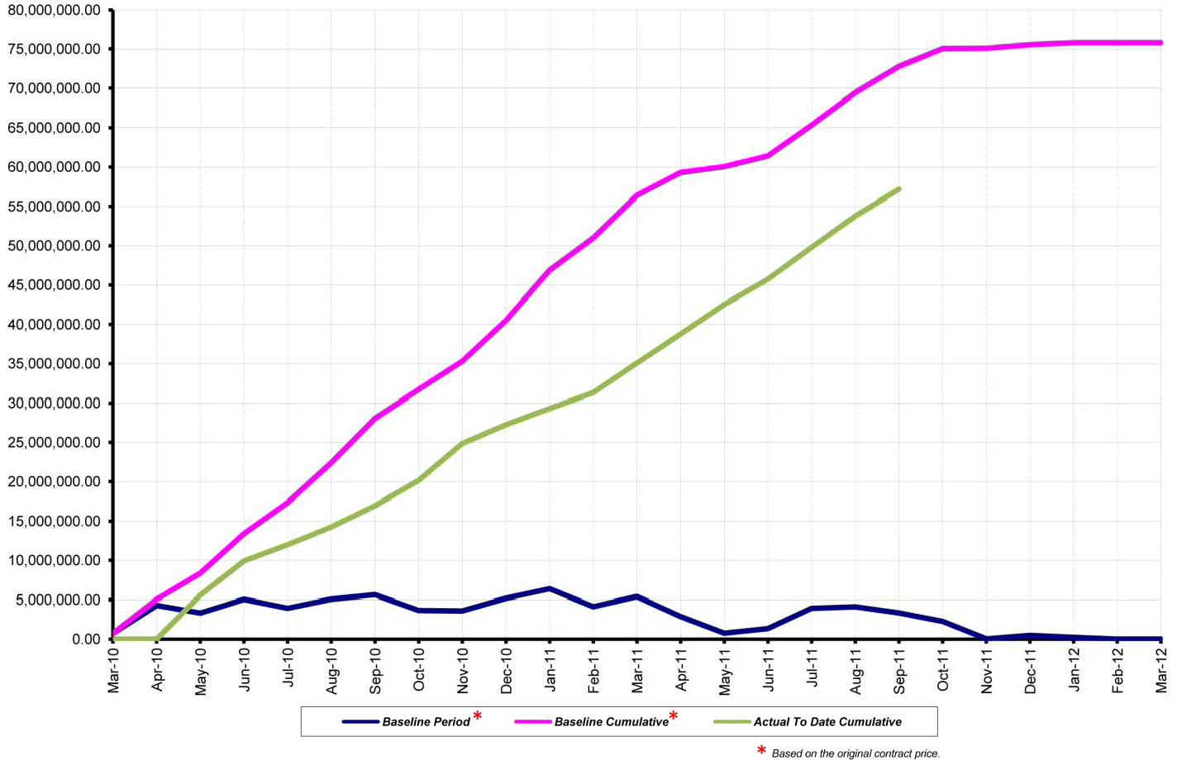

**Figure 2:**

**Project Baseline Cash Flow Curve for Period Ending September 2011**

# DBE STATUS

Webber is requested to meet the Disadvantaged Business Enterprise (DBE) goal of 11.62% for the project. The total DBE amount subcontracted to date is $8,928,110 which is 11.78% of the current authorized contract total. This represents executed DBE subcontracts with the following firms: N-Line, Royal Vista, Roadway Specialties, Trevcon (terminated), and Indus. To date, the DBE firms have been paid a total of $6,871,326 which is 78% of the DBE goal amount.

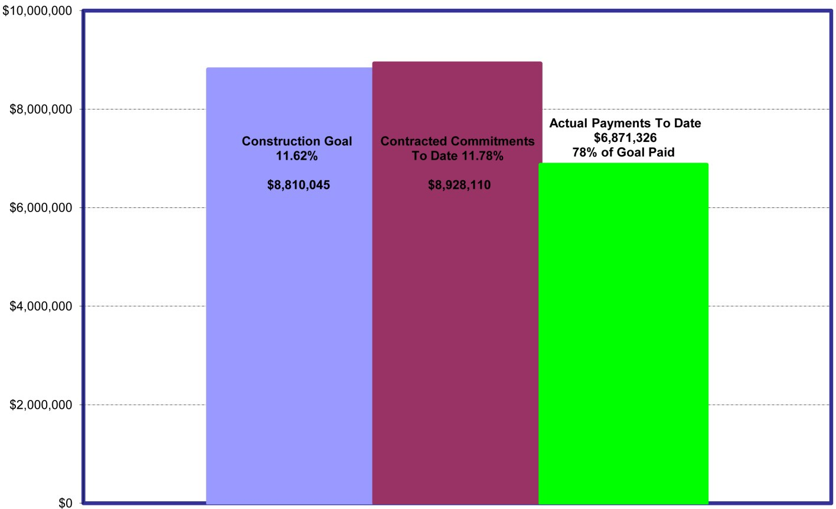

**Figure 3:**

**DBE Construction Commitment vs. Payment for Period Ending September 2011**

# EMPLOYMENT REPORTING STATUS

Construction of Phase II of the 183A Turnpike Project is estimated to have supported **318 jobs** during the reporting month of September 2011. This estimated number of jobs supported by the construction includes: the construction personnel and their subcontractors; construction management staff, including inspectors and subconsultants; design support staff; and the general engineering consultant staff and their subconsultants. The estimated total payroll associated with the jobs and work effort for September 2011 is **$542,284**.

# SUSTAINABILITY

The 183A Phase II Construction team launched the "Green Construction" initiative in September 2010. Through use of warm mix asphalt and recycling, the construction team is promoting sustainability and environmental responsibility. The following table indicates the total quantity used or recycled for each of the items under the Green Construction initiative as of September 2011.

|  |  |
| --- | --- |
| **Warm mix asphalt**  Warm mix asphalt allows a reduction in the temperature at which asphalt  mixtures are produced and placed. These reductions have the benefit of cutting fuel consumption and decreasing the production of greenhouse gases. | **13,690 tons** |
| **Recycling at the construction site**  At the job sites, the following is collected for recycling: scrap steel; plastic containers; steel, tin, and aluminum cans; glass bottles and jars. | **14 tons** |
| **Recycling at the Webber and HNTB field offices**  At the field offices, the following is collected for recycling: newspapers and magazines; any kind of paper; calculator tape; carbonless forms; brochures and pamphlets; manila folders; plastic containers; steel, tin, and aluminum cans. | **1.3 tons** |

# PUBLIC INVOLVEMENT

The Mobility Authority's Public Involvement Team manages the 183A hotline (512-684-3256) and the project website (183A.com). Lane closures and construction alerts are regularly posted on the project website as well as posted on the project Twitter account (@183AExtension). Additionally, stakeholders can sign up on the project website for lane closure information to be sent directly to their cell phone via SMS text.

During the reporting period, the team received one call in opposition to tolling as a way to finance transportation infrastructure. Another call was made regarding the 183A Phase I Project construction schedule, and the team was able to assist the resident with the information request. No calls or inquiries were received regarding the current 183A Phase II Project.

In August, the team provided an article for the Block House Creek Owners' Association (BHCOA) newsletter with the update that the new bridges over Scottsdale Drive would be open to the traveling public in late October 2011. When the bridges open, the Block House Creek neighborhood and Leander ISD will be informed.

Additionally, in response to the local wildfires, the BHCOA requested information from the team regarding what procedures the 183A construction crew is using to protect against wildfires. Included below, the information that the team provided was sent to the community via e-mail blast and is posted on the BHCOA website.

*For those who expressed concern during the Association’s meeting regarding protecting against wildfires and what procedures the 183A construction crew is using, here for you is their response to the question: “The 183A Northern Extension construction crew is committed to maintaining fire safety on the job at all times. When the team is performing cutting and grinding or welding activities, they ensure that they are at least 25 feet away from any vegetation, they pre-wet the area, and they always have a least one fire extinguisher within 10 feet of the activity. In addition, the team is aware of and conforms to the latest local ordinances regarding fire safety.”*

The team is working with the BHCOA on their upcoming Annual Harvest Fest that will be held Saturday, November 12. Similar to the team's participation in the event last year, the Mobility Authority will be providing a booth and making arrangements for an appearance from the American Hockey League's Texas Stars players and Ice Girls to sign autographs and give out raffle prizes. During this ongoing coordination process, the team was provided this statement from the BHCOA: "*The [Mobility Authority] has been a strong proponent of communication with our residents during your project, and in particular with your current bridge project (which we are all very excited about having completed!)*."